**EXPERIMENT 2: SAMPLING**

**AIM:** To perform sampling and reconstruction of signal by simulation. Also plot the frequency spectrum of each signal.

**THEORY:**

**Sampling**: In [signal processing](https://en.wikipedia.org/wiki/Signal_processing), sampling is the reduction of a c[ontinuous-time signal](https://en.wikipedia.org/wiki/Continuous-time_signal) to a [discrete-time signal](https://en.wikipedia.org/wiki/Discrete-time_signal).

**Sampling frequency**: The frequency at which a data set is sampled is determined by the number of sampling points per unit distance or unit time, and the sampling frequency is equal to the number of samples (or stations) divided by the record (or traverse) length.

**Nyquist frequency:** The minimum rate at which a signal can be sampled without introducing errors, which is twice the highest frequency present in the signal.

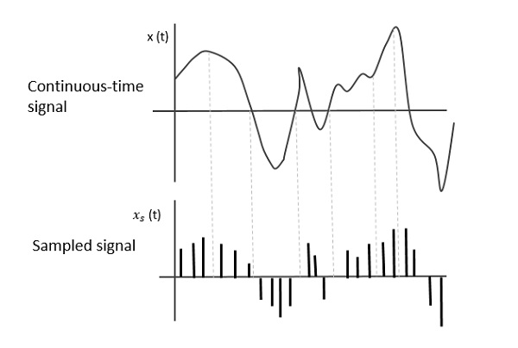

**PROGRAM:**

*//Given analog signal*

f1=100

t=-10:(1/f1):10

fa=1

x=cos(2*%pi*fa*t)

subplot(331)

plot(t,x)

xlabel('time')

ylabel('amplitude')

title('Given analog signal')

*//Frequency spectrum of given analog signal*

df=f1/length(t)

f=-f1/2:df:f1/2-df

Xf=fft(x)

Xf=fftshift(Xf)

subplot(332)

plot(f,Xf)

xlabel('freq')

ylabel('amplitude')

title('Frequency spectrum of given analog signal')

*//Impulse train*

fs=10

y=zeros(1,length(t))

y(1:f1/fs:length(t))=1

subplot(333)

xlabel('time')

ylabel('amplitude')

title('Impulse train')

plot(t,y)

*//Frequency spectrum of impulse train*

Xf_impulse=fft(y)

Xf_impulse=fftshift(Xf_impulse)

subplot(334)

plot(f,abs(Xf_impulse))

xlabel('freq')

ylabel('amplitude')

title('Frequency spectrum of impulse train')

*//Sampled response of given analog signal*

y1=zeros(1,length(t))

y1=x.*y

subplot(335)

xlabel('time')

ylabel('amplitude')

title('Sampled response of given analog signal')

plot(t,abs(y1))

*//Frequency response of sampled signal*

y2_sampledfreq=fft(y1)

y2_sampledfreq=fftshift(y2_sampledfreq)

subplot(336)

plot(f,abs(y2_sampledfreq))

xlabel('freq')

ylabel('amplitude')

title('Frequency response of sampled signal')

*//Rectangular filter*

hf=zeros(1,length(f))

for i=1:1:length(f)

if((f(i)>=-1.2)&(f(i)<=1.2))

hf(i)=10

end

end

subplot(337)

plot(f,abs(hf))

xlabel('freq')

ylabel('amplitude')

title('Rectangular filter')

*//Spectrum of sampled signal after rectangular filter*

y3=zeros(1,length(t))

y3=hf.*y2_sampledfreq

subplot(338)

plot(f,abs(y3))

xlabel('freq')

ylabel('amplitude')

title('Spectrum of sampled signal after rectangular filter')

*//Reconstructed signal*

orig=zeros(1,length(t))

orig=ifftshift(y3)

orig=ifft(orig)

subplot(339)

plot(t,orig)

xlabel('time')

ylabel('amplitude')

title('Reconstructed signal')

**RESULT:**

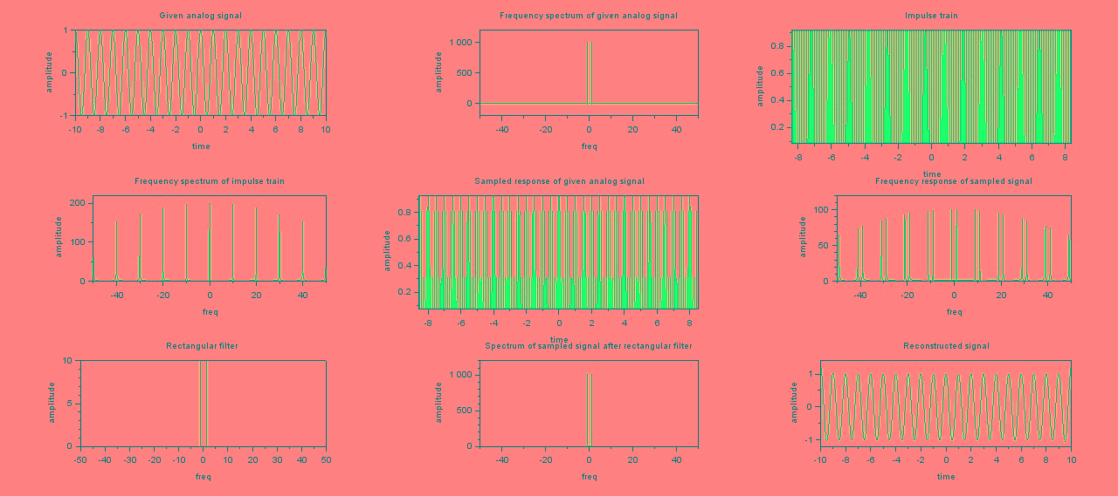

**CONCLUSION:**

We have successfully performed sampling and the reconstruction of signal.